

C L E

**Culture Learning Experience**

Project report

Fadi Hussien Allabban 2040615 Muhammad Sagr ALzahrani 1935819

# Scope Definition



## Culture Learning Experience (CLE) is a small start-up organization managing excursions, educational programs, and courses for teachers and students all over the world. The problem with the institution lies in the fact that the company’s work is completely manual, and this issue affects it very negatively, so many problems occur, and they are spread throughout the world at the same time, so they need a new system that is effective, fast, and comfortable for the user.

**Problem Analysis**

The most important problem in the organization is the reliance on manual work in the era of technology because it is difficult to organize and therefore when analyzing the problem we note the following:

1. **Customer comfort is always at the lowest possible level.**
2. **The possibility of error when recording information and affects performance.**
3. **When an organization is around the world, the organization needs to build a database because manually recording data is very difficult.**

Goals:

1. **Raising customer comfort to the highest possible level.**
2. **Creating a system to facilitate the recording of information in order to increase performance.**
3. **Having a database that holds all the existing data is key.**

**Requirements**

**Analysis**

The new system requirements are the following:

User interface that is both convenient and adaptable. Ease of entering, modifying, and deleting data.

The system must be be compatible with windows and Microsoft office 2010 system.

Creating or preparing a financial report and statement.

Marketing development and creation of marketing reports.

Strong system protection through strong ciphers or passwords.

There are simple restrictions, and the new project is limited, and the budget is 65,000$

**Identification and analysis**

**of candidate solutions Candidate solutions**

**We provided and listed some candidate solutions that can help the organization get over its issues as mentioned below**

**We have suggested three proposed solutions which might boost the company performance as the following:**

* 1. **Build a system from scratch.**
  2. **establish a system by using programming libraries. 3-purchase a pre-designed.**

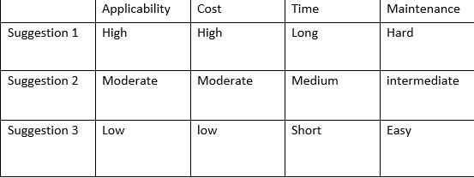

**The above table compares the three systems by using multiple factors.**

**Analysis of suggested solution**

**Recommended Solution**



after comparing the choices, we have decided to select

the second system because it has better features and fewer flaws such as applicability, cost, the time required and maintenance compared to the other systems.

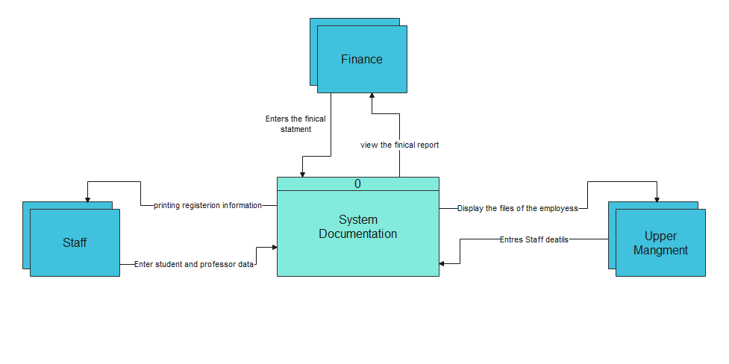**Context Digram(Current System):**

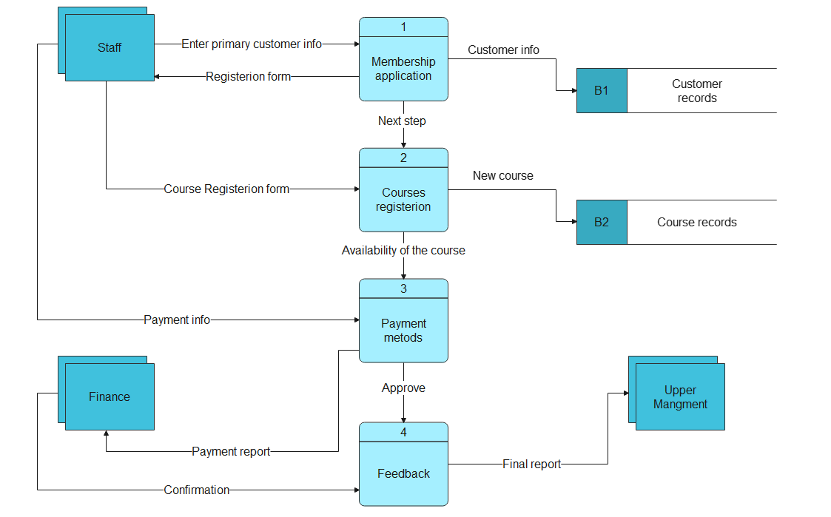**DFD (CURRENT SYSTEM)**

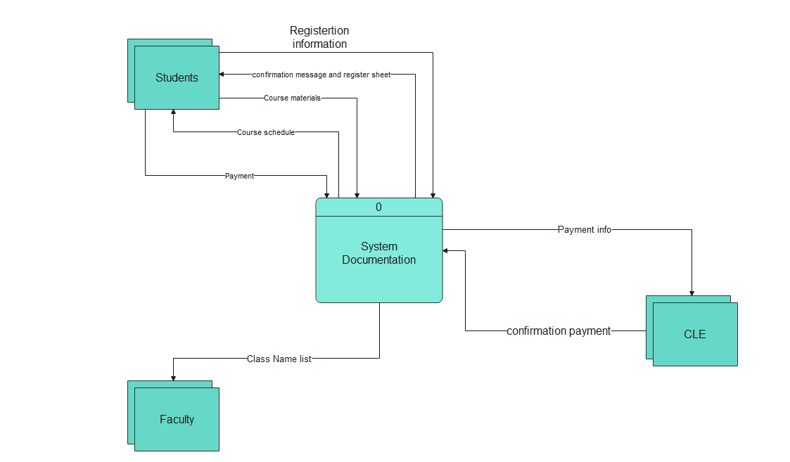**Context Digram (Proposed System)**

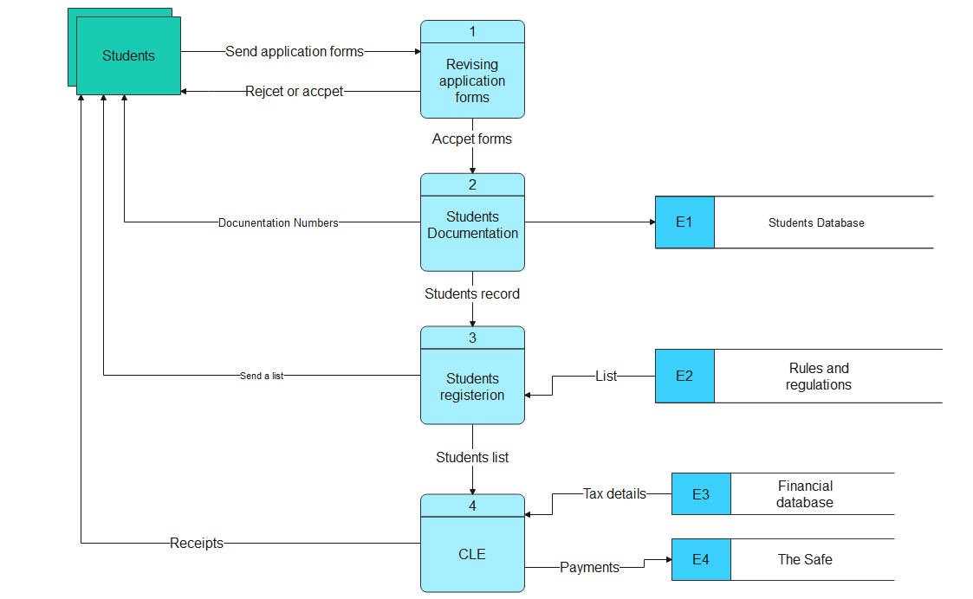DFD (Proposed System)

**Data Dictionary**

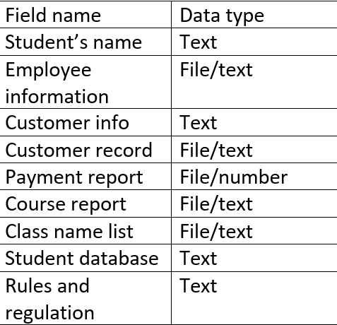

**Project Presentation**

Ctrl + Click to auto join

<https://youtu.be/hXJefBFEOnU>

# Thank you